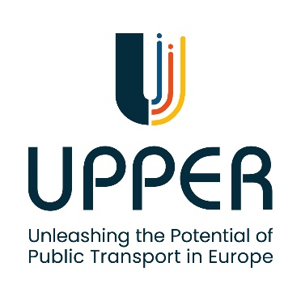
VAL_06: To improve the PT offer in peri-urban areas

Description of the measure and main outcomes expected

This measure aims to improve the accessibility to public transport in peri-urban areas of Valencia, which are currently poorly served by traditional bus services. The measure proposes the creation of an automated Demand-Responsive Transport (DRT) system (mobile application/web service for booking and tracking DRT services) to cater to the needs of people living in these areas with low accessibility to public transport. This measure aims to promote social inclusion by ensuring equitable access to essential services and opportunities for all Valencia residents, regardless of their location.
This measure will deliver:
- An automated Demand Responsive Transport (DRT) system (Mobile application & Interactive Voice Response - IVR) for booking and tracking the DRT service.
Communication campaign to promote the use of the DRT service among target users.
Preparation of the measure

Definition of the area and the use cases of the DRT service
EMT wishes to carry out a DRT pilot to cover peri-urban areas with low demand of PT and where there is no regular bus service. The area selected for the pilot is located in the maritime area, next to the Nautical Club, an area where demand is low and normally concentrated in specific time slots, coinciding with the entrance or exit from work.
The DRT service offered by EMT does not contemplate the creation of an on-demand route. Instead, the DRT service consists of establishing, within a fixed EMT route, a series of stops to which the bus only deviates upon express request of a user . This service must be able to be requested by any user interested in getting on the bus in the defined area, without the service request mechanism being a barrier. To solve that, three different service request mechanisms have been defined:
- Mobile APP/ Web service: Targeted at users with mobile phone and internet connection.
- IVR service (call service): Targeted at users with mobile phone but with no internet connection or low digital skills.
- Physical button in the stop: Targeted at users without mobile phone. This is beyond the scope of UPPER project, but their Use Case is also to be considered.
Based on that, the following use cases have been defined.
Request the DRT service though a mobile with internet connection
ID | VAL06_UC01
Description | A user who works at the Nautical Club has just finished work and is heading to the bus stop to catch the bus back home. The user knows that there is no fixed route that passes through this stop; instead, they must request the on-demand bus service (DRT). The user has a mobile phone and good digital skills. They open the DRT service app and follow the steps to request the on-demand bus. The app confirms whether there is a bus available to pick them up and sends a notification with the estimated waiting time until the bus arrives. If the waiting time is too long for the user, they can cancel the request. Similarly, if the assigned bus cannot fulfil the request for any reason, the user is informed, and the bus assignment process restarts.

Request the DRT service though a mobile without internet connection
ID | VAL06_UC02
Description | A user who visits the Nautical Club for leisure is heading to the bus stop to catch the bus back home. The user knows they need to request the DRT service but has limited digital skills and prefers not to download the DRT service APP. Instead, the user chooses to request the service via phone call. They call the provided number and follow the Interactive Voice Response instructions to request the on-demand bus. The user receives an SMS confirming if there is a bus available to pick them up, along with an estimated wait time until the bus arrives.

Request the DRT service without a mobile (Development beyond the scope of UPPER project)
ID | VAL06_UC03
Description | A user who usually goes to the Nautical Club to work, wants to catch the bus back home. The user knows that there is a bus stop in front of the Nautical Club that offers an on-demand bus service. The user goes to the stop, but does not have a mobile phone to request the service. The user approaches the button located at the stop, specifically for requesting the DRT service. This button connects the user to an Interactive Voice Response system, which provides guidance for making the request.

Definition of technical requirements and architecture.
After some bilateral discussions between ETRA (which develops the APP and the DRT management system for the PTO) and the DRT service provider (EMT), a list of technical requirements was defined for serving properly the abovementioned use cases. The technical requirements are presented in the table below.
Table 4 DRT system (Table of requirements)
ID | Technical Requirements | Category
VAL06_TR01 | The solution must provide a mobile app that allow users to book a ride and provide accurate vehicle location updates | Usability
VAL06_TR02 | The solution must include an Interactive Voice Response (IVR) system that enables users to book a ride via a phone call when they do not have internet access on their devices | Usability
VAL06_TR04 | The mobile app should be intuitive and have an easy-to-navigate interface for users to book a ride and track vehicles | Usability
VAL06_TR05 | A booked ride through the mobile app should be automatically cancelled when the user has subsequently moved away from the stop | Usability
VAL06_TR06 | The mobile app should allow users to cancel a booked ride easily | Usability
VAL06_TR07 | The mobile app should display a map showing the real-time location of the vehicle and the corresponding route depicted | Security
VAL06_TR08 | The mobile app should request permissions to access the device's GPS and notification system | Data
VAL06_TR09 | The users should be able to select the stop, route and headsign when booking a new ride through the mobile app | Data
VAL06_TR10 | Both the mobile app and the IVR system will not need registration and login to be used | Usability
VAL06_TR11 | The IVR system should offer multiple language options for voice prompts that allow users to be comfortable when they book a ride | Usability
VAL06_TR12 | The IVR system must send an automated SMS notification after the call is finished | Usability
VAL06_TR13 | The IVR system SMS content must be the ride confirmation and the vehicle arrival time, or a not availability service message | Usability
VAL06_TR14 | The users should be able to select the stop and headsign when booking a new ride through the IVR system | Data
VAL06_TR15 | The most proper vehicle associated to a ride must be selected by an EMT operator using a GUI | Usability
VAL06_TR16 | The GUI used by an EMT operator should show the available vehicles to be selected | Data
VAL06_TR17 | The EMT operator should be able to select a vehicle on the GUI and activate the notification to the vehicle driver | Usability
VAL06_TR18 | The GUI should show if the driver has accepted or rejected the trip deviation | Usability
VAL06_TR19 | EMT must provide the corresponding actions to let the driver to receive the notification of trip deviation or cancellation | Usability
VAL06_TR20 | The drivers must be able to accept or reject the deviation trip request | Usability
VAL06_TR21 | The solution must efficiently match users with available vehicles based on proximity and route optimisation | Usability
VAL06_TR22 | The application must be able to run on mobile phones operating in Android OS and iOS. | Compatibility

Based on the technical requirements established and the use cases described, ETRA proceeded with the definition of the architecture for the DRT system. The flowchart for the DRT system is detailed below:
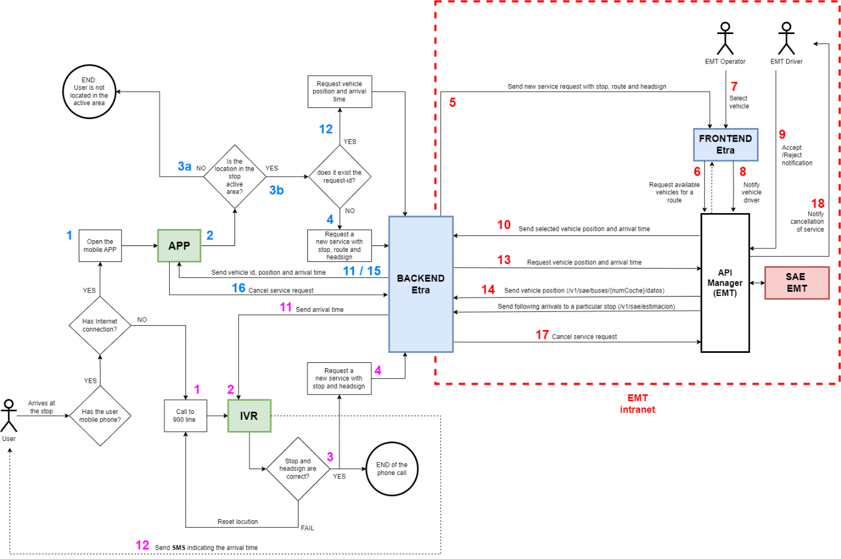
Figure 1 - DRT system architecture
USE CASES – Mobile APP (UC01):
- (1) A user wants to request an on-demand bus service (DRT). To do so, the user opens the mobile APP, which offers a list of routes with off-route stops.
- (2) The user selects the route, the route direction and the bus stop of interest (among the possible ones) in the mobile APP, and then requests the service.
- (3a) The APP checks that the user’s position is close to the stop. If it is not close, the user is notified that he/she must be next to the stop with the mobile device to be able to request this service. (3b) If this is the case, the system searches for the next available bus for the selected route.
- (4) If it doesn’t exist a current service for the user, it is requested a new one with the stop, route and headsign selected.
- (12) If it exists a current service requested, the app itself requests the vehicle position and arrival time every 20s – 30s, to be displayed.
- (5) At the EMT side, a frontend app receives the request of a new service.
- (6) That frontend app displays the available vehicles provided by the EMT API.
- (7) An EMT operator selects a vehicle and accepts the service on the frontend app, and this sends a notification to the vehicle selected.
- (8) The fronted app sends a notification to the driver. If no bus is found to be available, it notifies the user that there is no service available at that time.
- (9) If the notification arrives to a vehicle, the driver accepts or rejects it.
- (10)(11) The vehicle position selected and the current arrival time is sent to the user of the app.
- (12)(13) As long as the user does not cancel the service, the mobile APP will show the position of the assigned bus on a map. This position will be provided by the system of EMT.
- (14) The system of EMT returns the vehicle position and arrival time via API.
- (15) The app updates the vehicle position and arrival time.
- (16) The user can cancel a service request when moving away from the stop, either by walking or by getting on the bus itself.
- (17) The service is cancelled via the API of EMT.
- (18) The system of EMT notifies the service cancellation to the EMT driver, either because the user has already got on the bus or because the user has moved away from the stop.

USE CASES – IVR (UC02):

- (1) If the user does not have Internet connection, he/she can call a phone number to request a new DRT service, in a similar way as he/she would do using the app.
- (2) The IVR system will request the stop where the user is located and the headsign where he/she wishes to go.
- (3) The information given by the user is validated and if so, the call ends.
- (4) The IVR system will request a new DRT service to the EMT system.
- (5) At the EMT side, the frontend app receives the request of a new service. In this case, coming from the IVR system.
- (6) Again, the EMT system provides with the available vehicles and the frontend app displays them to the EMT operator.
- (7) The EMT operator selects the vehicle and accepts the service on the frontend app.
- (8) Finally, the frontend sends a notification to the selected vehicle’s driver.
- (9)(10) If the driver accepts the notification of a new DRT service, the EMT system returns the arrival time to the IVR system.
- (9) If the driver rejects the notification, the EMT operator will select other vehicle and again the new driver will accept or reject the new DRT service.
- (11) The IVR system receives the arrival time of the EMT vehicle.
- (12) The IVR system sends a SMS message to the user who did the call requesting a new DRT service with the arrival time.

Mobile application/ web service development
At this stage of the project, the APP and the IVR service to request the DRT service have been properly developed, following the technical requirements defined at the beginning of the measure preparation. The figures below show the APP developed.
Mobile APP screen captures:
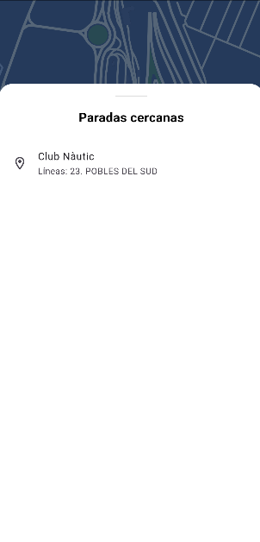  Figure 2 - Nearest available stops | 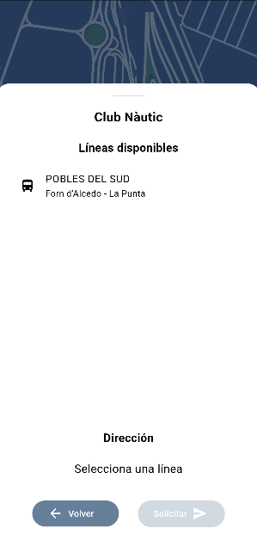  Figure 3 - Bus line selection after selecting the stop | 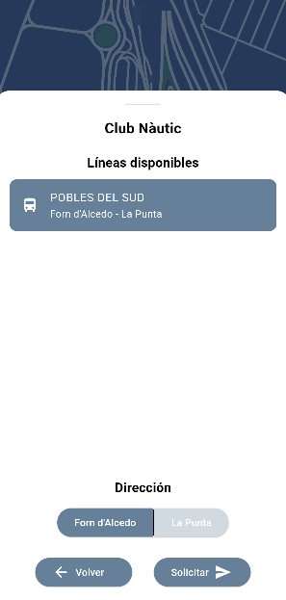  Figure 4 - Headsign selection after selecting the bus line
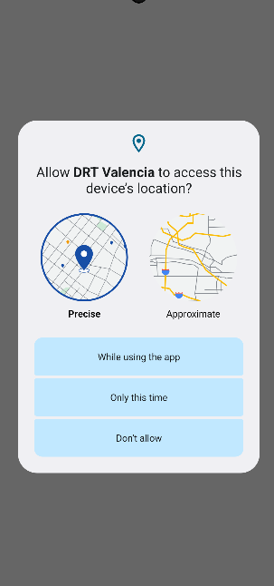  Figure 5 - Allowing access to location services | 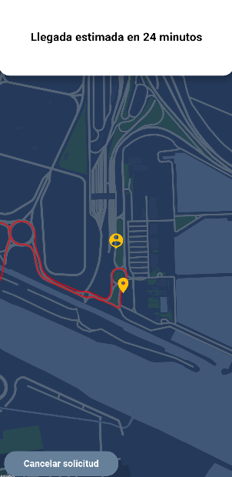  Figure 6 - Estimated arrival time displayed | 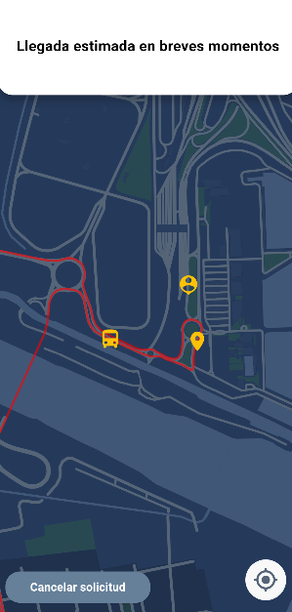  Figure 7 - The selected bus is arriving

IVR - SMS received by the user with the arrival time:
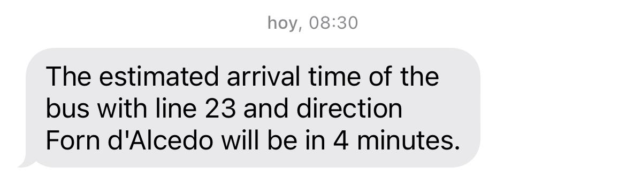
Figure 8: Model of SMS with estimated arrival time

Challenges & Mitigations

No challenges were identified, the measure preparation went according to the plan.
Next steps towards implementation

The next steps towards implementation include:
- Training EMT staff for running the service.
- Launch a communication campaign to inform about the new DRT service and promote its usage and train target users on how to use it.

